Things You'll Need for a Plywood Billboard
- Tape measure
- Level
- Treated pine post, 4-by-4-by-96-inches
- Treated plywood, 3/4-inch, 48-by-96-inches
- Screw gun/drill
- Various drill bits
- wood screws, 3-inch
- Grommet setting tool and grommet rings
- 4-6 inch UV resistant zip ties
- Post hole digger
- Hammer
- 2 landscaping stakes, 20-inch
- 1 Cubic foot of concrete mix
- Optional: skinny cabled bike locks
96”

48”

72”

24”

12”

- Lay the post flat and set the plywood on top of it one of the 96-inch edges is flush with the end of the post. Position the plywood so the 48-inch edges are each 16 inches away from the sides of the post. Screw the plywood to the post using screws every 4-8 inches.
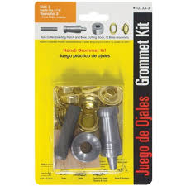
Securing your billboard to the plywood: You will need to drill holes around the edges of the plywood to provide somewhere to secure your vinyl billboard to the billboard. These holes should line up with grommets of the billboard and be approximately the same size. Most billboards come with about 4 grommet holes (one at each corner). Other holes can be made in your vinyl billboard with a simple grommet setting tool that can be purchased at any hardwood store. 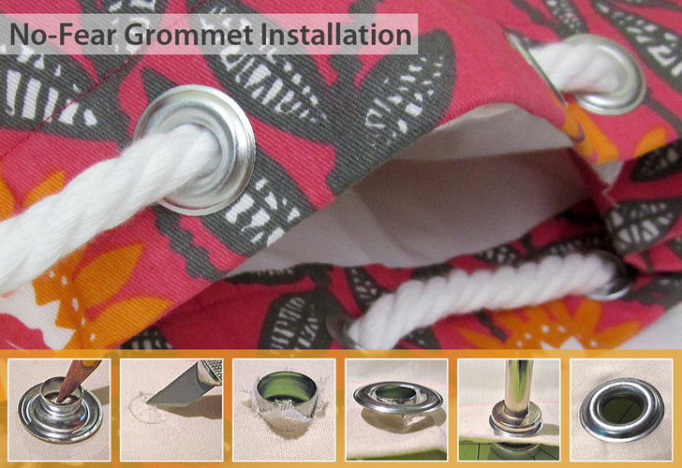
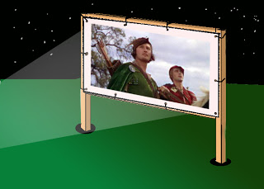
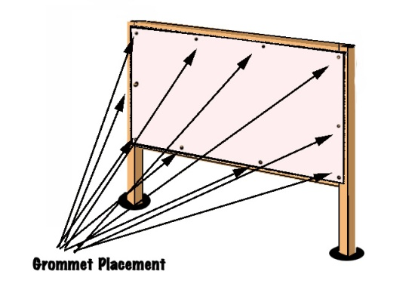
With either method: Now that you have holes drilled in the plywood, you can attach your billboard to the plywood using 4-6 inch UV resistant zip ties. Make sure you have enough grommets in the billboard to firmly attach your vinyl to the plywood. I suggest at least 3-4 on each edge of the vinyl. Try to smooth out all the wrinkles in the vinyl as you are securing the billboard to the plywood…make sure everything is pulled tight.
Note: There was some concern on the Colville Reservation that the billboard would be stolen. I secured my billboards with the above mentioned method, but also used an extra large grommet hole (which I created) and skinny bike lock to tie the whole thing to the plywood.
- Dig a 12-inch-wide, 24-inch-deep hole where you would like to display your billboard. Use your post hole digger. This hole will make the top of your billboard 72 inches above the ground.
- Set the post with the plywood in the hole(s) and position it so it is perpendicular to the ground using your level. Pound a landscaping stake on two sides of the post so the stakes are at right angles with each other. The stakes should be at a 45-degree angle to the ground and the tops of the stakes should be flush with the ground. They will hold the post in the perpendicular position as the cement cures.
- Pour your cement mix in the hole surrounding the post and let it cure according to instructions.

